**Title : Report on Air Pollution and Noise Pollution: Insights from Local Authorities**

**1. Introduction**

This report presents an analysis of air and noise pollution based on data collected from local authorities. Pollution, whether in the form of harmful gases or excessive noise, poses a significant threat to public health, the environment, and overall quality of life. By examining the levels and sources of air and noise pollution, we can better understand their impacts and devise effective measures to mitigate them.

1. Air Pollution

a. Key Air Pollutants

The data from local authorities revealed several major pollutants that contribute to air quality degradation. These include:

- Particulate Matter (PM2.5 and PM10) : Fine particles suspended in the air, typically from vehicle emissions, construction activities, and industrial processes.

- Nitrogen Dioxide (NO2) : Released from the combustion of fossil fuels, particularly from vehicles and power plants.

- Sulfur Dioxide (SO2) : Emitted from industrial processes, especially from coal-burning plants and refineries.

- Carbon Monoxide (CO) : Mainly emitted by motor vehicles and industrial activities.

- Ground-level Ozone (O3) : Formed by the reaction of sunlight with pollutants such as volatile organic compounds (VOCs) and nitrogen oxides (NOx).

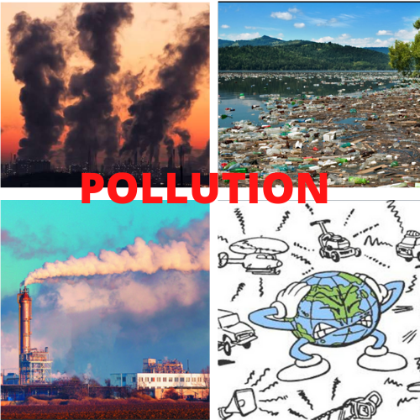

b. Air Quality Data (from Local Authorities)

- PM2.5 and PM10 levels : The average PM2.5 concentration was found to be 65 µg/m³ , while PM10 levels reached 90 µg/m³ , both exceeding the World Health Organization's recommended limits.

- NO2 levels : NO2 concentrations averaged 45 µg/m³ , primarily in urban areas with heavy vehicular traffic.

- SO2 and CO levels : SO2 and CO levels remained relatively low in most areas, but industrial zones showed elevated concentrations.

c. Sources of Air Pollution

- Traffic emissions : The largest contributor, particularly in congested urban areas.

- Industrial activity : Factories, power plants, and refineries release significant amounts of pollutants.

- Construction : Dust and particulates from construction sites contribute to local air quality issues.

- Burning of fossil fuels : Residential areas where coal and wood are burned for heating also show elevated pollution levels.

d. Impact on Health

Air pollution is linked to a range of health problems, including:

- Respiratory issues : Asthma, bronchitis, and lung infections are common in high-pollution areas.

- Cardiovascular diseases : Long-term exposure increases the risk of heart disease and stroke.

- Premature deaths : An estimated 30,000 premature deaths annually are attributed to air pollution-related health conditions.

**2. Noise Pollution**

a. Key Noise Pollutants

Noise pollution is primarily generated by:

- Traffic noise : Vehicles, honking, and heavy traffic congestion contribute significantly to noise levels.

- Construction activities : Ongoing construction and infrastructure development create high-decibel noise.

- Industrial noise : Factories and other industrial facilities generate constant, high-decibel sounds.

- Public events and loudspeakers : Music, announcements, and public gatherings also contribute to elevated noise levels in specific areas.

b. Noise Levels (from Local Authorities)

- Residential areas : Average noise levels ranged between 65 to 75 dB , which is above the permissible limit of 55 dB for residential zones.

- Commercial areas : Noise levels reached up to 85 dB , exceeding the permissible limit of 65 dB .

- Construction zones : In areas with ongoing construction, noise levels peaked at 95 dB , contributing to significant disturbances.

- Public spaces : During festivals and events, noise levels spiked to over 100 dB , particularly in areas with loudspeakers and firecrackers.

c. Sources of Noise Pollution

- Vehicular traffic : Traffic jams, engine sounds, and constant honking.

- Construction : Machinery, drilling, and heavy equipment usage.

- Public celebrations : Firecrackers, music systems, and processions in residential areas.

- Industrial machinery : Factories and workshops contribute to persistent noise.

d. Impact on Health

Exposure to prolonged or high-decibel noise can lead to:

- Hearing loss : Sustained exposure to noise levels above 85 dB can cause permanent damage to hearing.

- Sleep disturbances : High noise levels disrupt sleep, leading to stress and fatigue.

- Mental health effects : Continuous exposure to noise pollution contributes to anxiety, irritability, and cognitive impairments.

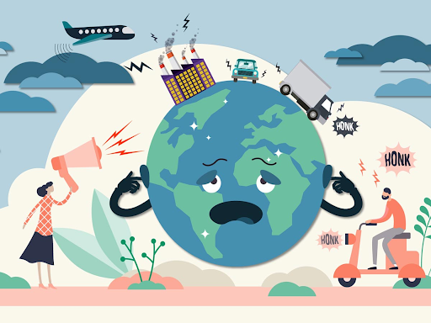

**3. Comparison and Key Findings**

- Air Pollution : The primary sources of air pollution are vehicular traffic and industrial emissions. Both particulate matter and nitrogen dioxide exceed safe limits, posing severe health risks to the population.

- Noise Pollution : Traffic, construction, and public events are the major contributors to noise pollution. Noise levels frequently exceed recommended limits, particularly in urban and industrial areas, impacting both physical and mental health.

**4. Recommendations**

Based on the data, the following measures are recommended:

- Traffic management : Introduce stricter emission regulations, promote public transportation, and encourage the use of electric vehicles to reduce air pollution.

- Industrial regulations : Implement stricter controls on emissions and ensure proper waste management in industrial zones.

- Green spaces : Increase urban green spaces to absorb pollutants and buffer noise.

- Noise control : Enforce regulations on noise levels in public areas, particularly during events, and encourage the use of noise barriers near highways and construction sites.

- Public awareness : Educate the public about the dangers of both air and noise pollution and encourage the adoption of eco-friendly practices.

**5. Effects of Air and Noise Pollution**

**5.1 Health Impacts**

Air and noise pollution pose serious health risks to the population. Based on the data from local health authorities, the following health impacts have been observed:

* **Air Pollution Health Risks:**
  + **Respiratory Issues:** High levels of particulate matter (PM2.5) contribute to respiratory diseases such as asthma, bronchitis, and chronic obstructive pulmonary disease (COPD).
  + **Cardiovascular Diseases:** Long-term exposure to air pollutants like nitrogen oxides and sulfur dioxide increases the risk of heart attacks, strokes, and other cardiovascular diseases.
  + **Premature Mortality:** Exposure to high levels of air pollution is linked to premature deaths, particularly among the elderly and those with pre-existing health conditions.
* **Noise Pollution Health Risks:**
  + **Hearing Impairment:** Prolonged exposure to high noise levels can lead to hearing loss, especially in individuals living near noisy industrial zones or heavy traffic areas.
  + **Sleep Disturbances:** Noise pollution, especially at night, disrupts sleep patterns, leading to stress, fatigue, and impaired cognitive function.
  + **Mental Health:** Constant exposure to loud noise contributes to increased anxiety, stress, and depression.

**5.2. Environmental Impacts**

* **Air Pollution:** High concentrations of pollutants such as sulfur dioxide and nitrogen oxides contribute to acid rain, which damages soil, water bodies, and vegetation. Moreover, air pollution worsens global warming, contributing to climate change.
* **Noise Pollution:** Noise disrupts wildlife, interfering with communication, reproduction, and migration patterns, particularly for birds and marine animals.

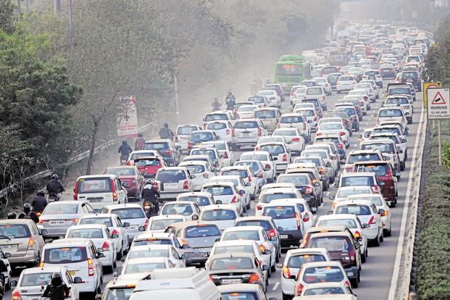

**6. Efforts to Control Air and Noise Pollution**

**6.1. Government Policies and Initiatives**

Local authorities have implemented various policies to mitigate air and noise pollution, including:

* **Vehicle Emission Standards:** Stricter emission norms for vehicles, coupled with the promotion of electric and hybrid vehicles, have been introduced to reduce vehicular emissions.
* **Industrial Regulations:** Industries are required to adopt cleaner technologies and install pollution control equipment to minimize emissions.
* **Noise Control Measures:** Authorities have set noise limits for different zones and imposed restrictions on honking and loud construction activities, particularly in residential areas.

**6.2. Public Awareness Programs**

Public awareness campaigns have been launched to educate people about the dangers of air and noise pollution. These campaigns encourage the use of public transportation, carpooling, and noise reduction practices, such as minimizing the use of car horns and avoiding loud music in residential areas.

**Conclusion :**

The data highlights the pressing need for action to reduce both air and noise pollution in the region. While traffic and industrial emissions remain the dominant sources, a concerted effort from authorities, businesses, and the community is required to mitigate these environmental threats. Implementing sustainable solutions and raising public awareness will help ensure a healthier, more livable environment for all.